Wireshark Lab 1: Ethernet and ARP

Group Details:
Zhaoning Kong 1004654288
Qianhao Zhang 1004654377
Mark:

 | Question | Answer
1 | What is the 48-bit Ethernet address of your computer? | 3c:15:c2:b9:e1:8a  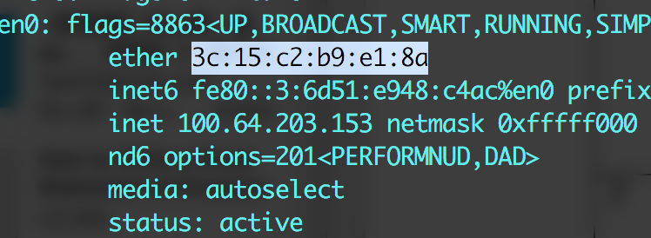
2 | What is the 48-bit destination address in the Ethernet frame?  What device has this as its  Ethernet address? | 00:90:0b:27:0f:b9  The first-hop router in our path to the destination address.  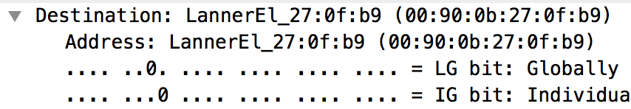
3 | Give the hexadecimal value for the two-byte Frame type field.  What upper layer protocol does this correspond to? | 0x0800  IPv4  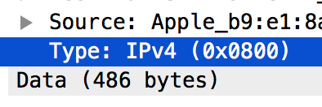
4 | How many bytes from the very start of the Ethernet frame does the ASCII “G” in “GET” appear in the Ethernet frame? | 66 bytes.  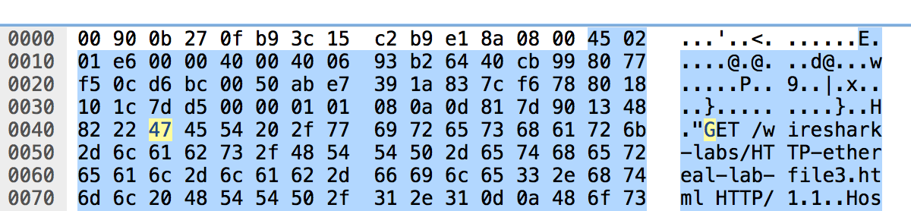
5 | What is the value of the Ethernet source address?  What device has this as its Ethernet address? | 00:90:0b:27:0f:b9  The first-hop router in our path to the destination address.  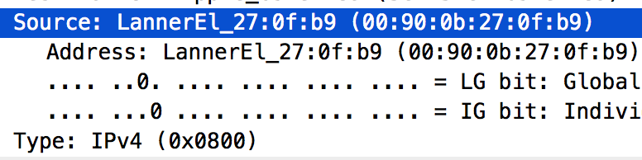
6 | What is the destination address in the Ethernet frame?  Is this the Ethernet address of your computer? | 3c:15:c2:b9:e1:8a  It is the ethernet address of my computer.  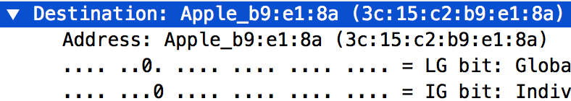
7 | Give the hexadecimal value for the two-byte Frame type field.  What upper layer protocol does this correspond to? | 0x0800  IPv4 Protocol.  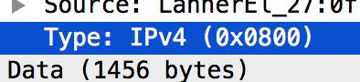
8 | How many bytes from the very start of the Ethernet frame does the ASCII “O” in “OK” (i.e., the HTTP response code) appear in the Ethernet frame? | 79  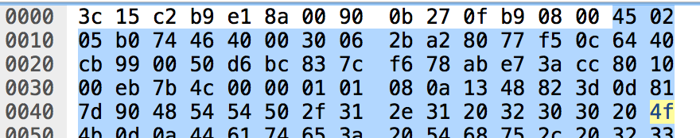
9 | Write down the contents of your computer’s ARP cache.  What is the meaning of each column value? | First column: Domain name  Second column: IP address  Third column: MAC address  Fourth column: Physical network interface name
10 | What are the hexadecimal values for the source and destination addresses in the Ethernet frame containing the ARP request message? | Source: 3c:15:c2:b9:e1:81  Destination: ff:ff:ff:ff:ff:ff  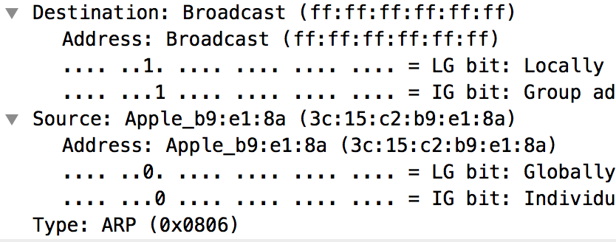
11 | Give the hexadecimal value for the two-byte Ethernet Frame type field.  What upper layer protocol does this correspond to? | 0x0806, ARP
12 | -
13 | -
14 | What are the hexadecimal values for the source and destination addresses in the Ethernet frame containing the ARP reply message? | Source: 00:90:0b:27:0f:b9  Destination: 3c:15:c2:b9:e1:8a  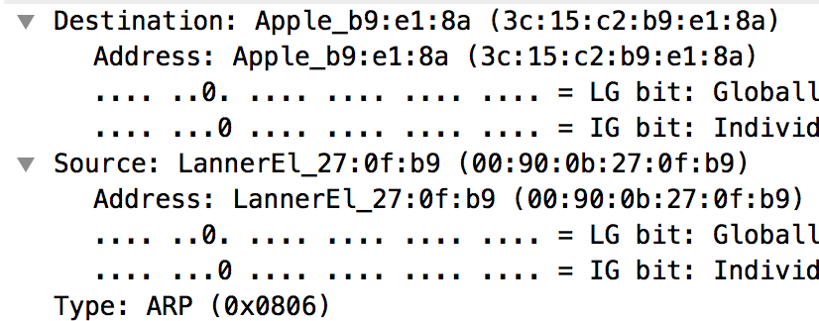  The source is the router, and the destination is my computer. After receiving this packet, I will know the MAC address of the router.
15 | -

